CSE3241 In-Class Activity –SQL Practice Lab
Work individually and turn it in at the end
Name: Qifan Wen (wen.679) Date: 10/31/2025

Rename this document and name it sql_studentlastname. Include all solutions on the answer sheet found at the end of this document. Submit this report at the end of class on Carmen under SQL_Lab. You need to have SQLite Studio installed on your device in order to complete this lab.

For this lab we will be using the database of a company that sells games. The database given consists of all the games and players who have purchased games. The given database contains initially 8 tables. Make sure you go through each table’s data and attributes before starting the lab. The relational database schema is provided too (see GameSchema.pdf).

Part 1: Creating and updating the database

1. Before starting the lab, download GameStore.sqlite file from Carmen (download the GameStore database file and then extract the file if needed). Import the database on SQLite Studio.
2. Create a new table called “Developer” with the following requirements.
    - Attributes:
      - DevID: INTEGER, Primary Key, NOT NULL
      - DevName: varchar(50)
      - GameName: varchar(50), FK referencing Game’s Name field
      - Address: varchar(60)
      - NumberOfEmployees: smallint
3. Add data to this table by importing the Developers.csv file.

4. Post the code you used to create Developer on the answer sheet (bottom of this file)

Part 2: Queries

1. Fill in the missing blanks of the following queries. Test and make them work. Post the completed query on the answer sheet (see last page on this file).
- List in alphabetical order the name and platform of all games that cost less than $50.00
SELECT Name, Platform
FROM Game
WHERE __________ < __________
ORDER BY __________;
- List Player names and the games they own for Players older than age 50.
SELECT PlayerName, Name
FROM Player, Owns
WHERE __________ = __________ AND __________ > __________

- List the player name and age of all players who have commented on a game of the FPS genre
SELECT Player.PlayerName, Player.Age
FROM Player
WHERE Player.Email IN (
SELECT ________________________
FROM Comment, BelongsTo
WHERE BelongsTo.Name = Comment.Name
AND ________________________ = ‘FPS’
);

2. Post the code of the following queries on the answer sheet.

- List the Name and Website of all games with a platform value of ‘All’.

- List the PlayerName and the number of games owned by the 2 customers with the highest number of games. List the rows in descending order by the number of games. (hint: check in SQLite documentation the clause LIMIT n)

- In the database each Game has a different price. List the average Game price for each Player. Order by average price in descending order.

- Each Player has Preferred genres of games. List all games, by player, that aren’t owned by the player, on its preferred Genre.

You need to return a list of player names, game names and genre (where that player prefers a genre but does not yet own those games).

3. Come up with your own query, briefly mention why do you think the results of the query might be useful for the company. Include at least one join and one operation from MAX/MIN/COUNT/AVG. Post your code on the answer sheet and briefly describe on English what the query does.

Part 3: Views

- Create a view that computes the total price of games sold to players by developer. Include the Developer, the number of employees, and the total price of games they have sold. Post the code of your solution on the answer sheet.

- Using this view, look up the average amount of sales for all developers. Post the code of your solution on the answer sheet.

Answer Sheet

Part 1: Creating and updating the database

Insert your code for creating Developer table:

CREATE TABLE Developer (
DevID INTEGER PRIMARY KEY NOT NULL,
DevName VARCHAR(50),
GameName VARCHAR(50),
Address VARCHAR(60),
NumberOfEmployees SMALLINT,
FOREIGN KEY (GameName) REFERENCES Game(Name)
);

Part 2: Simple and Nested queries
1.
a.
SELECT Name, Platform
FROM Game
WHERE Price < 50.00
ORDER BY Name, Platform;

b.
SELECT PlayerName, Name
FROM Player, Owns
WHERE Player.Email = Owns.Email
AND Player.Age > 50;

c.
SELECT Player.PlayerName, Player.Age
FROM Player
WHERE Player.Email IN (
SELECT DISTINCT Comment.Email
FROM Comment, BelongsTo
WHERE BelongsTo.Name = Comment.Name
AND BelongsTo.GenreName = 'FPS'
);

2.
a.
SELECT Name, Website
FROM Game
WHERE Platform = 'All';

b.
SELECT p.PlayerName, COUNT(o.Name) AS NumGames
FROM Player AS p
JOIN Owns AS o ON o.Email = p.Email
GROUP BY p.PlayerName, p.Email
ORDER BY NumGames DESC
LIMIT 2;

c.
SELECT p.PlayerName, AVG(g.Price) AS AvgPrice
FROM Player AS p
JOIN Owns AS o ON o.Email = p.Email
JOIN Game AS g ON g.Name = o.Name
GROUP BY p.PlayerName, p.Email
ORDER BY AvgPrice DESC;

d.
SELECT p.PlayerName, g.Name AS GameName, b.GenreName
FROM Player AS p
JOIN Preferred AS pr ON pr.Email = p.Email
JOIN BelongsTo AS b ON b.GenreName = pr.GenreName
JOIN Game AS g ON g.Name = b.Name
LEFT JOIN Owns AS o ON o.Email = p.Email
AND o.Name = g.Name
WHERE o.Email IS NULL
ORDER BY p.PlayerName, GameName;

3.
SELECT
b.GenreName,
COUNT(DISTINCT o.Email) AS NumOwners,
AVG(p.Age) AS AvgOwnerAge,
AVG(g.Price) AS AvgOwnedGamePrice
FROM BelongsTo AS b
JOIN Game AS g ON g.Name = b.Name
JOIN Owns AS o ON o.Name = g.Name
JOIN Player AS p ON p.Email = o.Email
GROUP BY b.GenreName
ORDER BY NumOwners DESC;

Part 3: Views
1.
a. Code
CREATE VIEW DeveloperSales AS
SELECT
d.DevID,
d.DevName AS Developer,
d.NumberOfEmployees,
COALESCE(SUM(g.Price), 0) AS TotalSales
FROM Developer AS d
JOIN Game AS g ON g.Name = d.GameName
LEFT JOIN Owns AS o ON o.Name = g.Name
GROUP BY d.DevID, d.DevName, d.NumberOfEmployees;
b. Screenshot:
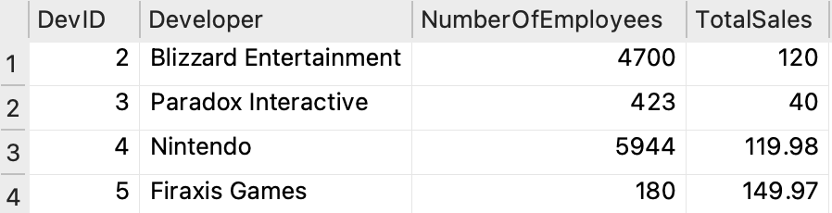
2.
a. Code
SELECT AVG(TotalSales) AS AvgDeveloperSales
FROM DeveloperSales;
b. Screenshot:
